The Carer’s Way Ahead: On-line support for families managing challenging behaviours
Researchers at UNSW Sydney (The University of New South Wales) and iCare are seeking volunteer research participants to learn about managing challenging behaviour for carers of people with Traumatic Brain Injury.
Would the research study be a good fit for me?
The study might be a good fit for you if:
- You have a family member with a traumatic brain injury
- You find some of their behaviour challenging
- You would like to help us evaluate an on-line program that is designed to help carers manage challenging behaviours

What would happen if I took part in the research study?
If you decide to take part you would:
- Complete on-line questionnaires.
- Complete a range of self-report measures before, during and after the study
- Be provided with access to the online program, which contains 7 online modules over a 10-week period.

Will I be paid to take part in the research study?
There are no additional costs associated with participation in this research study, nor will you be paid.
Who do I contact if I want more information or want to take part in the study?
If you would like more information or are interested in being part of the study please contact:
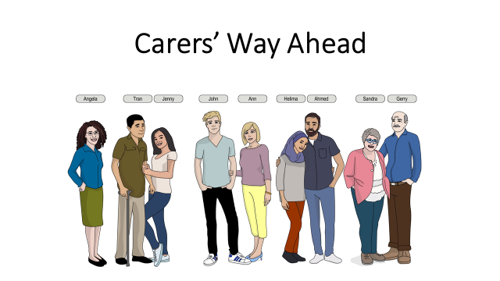
Name: Dr Travis Wearne
Email: t.wearne@unsw.edu.au
Phone: (02) 9385 3310
Website: https://redcap.link/thecarerswayahead

