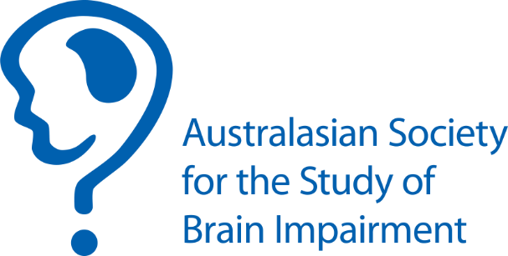

ASSBI Clinical Innovation Award Declaration and Signature/s
Please complete one of the following sections as applicable. This page needs to be submitted with your application. Email to Margaret Eagers (admin@assbi.com.au) by 1st February 2019.

- Application from a single applicant
This application is submitted by an early career clinician, and there are no team members.
Lead clinician name | Signature | Date

- Application from a team and led by an early career clinician
This application is submitted by a team led by an early career clinician.
Should the application be successful, we have discussed and agreed on the allocation of the award ($1,500 plus one ASSBI conference registration for 2019).
Lead clinician name | Signature | Date
Team member names | Team member signatures | Date
Add more rows as necessary

- Application from two early career clinicians (co-lead)
This application is submitted by two early career clinicians, and there are no team members.
Should the application be successful, we have discussed and agreed on the allocation of the award ($1,500 plus one ASSBI conference registration for 2019)

Lead clinician names | Signatures | Date

- Application from a team led by two early career clinicians
This application is submitted by a team and led by two early career clinicians.
Should the application be successful, we have discussed and agreed on the allocation of the award ($1,500 plus one ASSBI conference registration for 2019).
Lead clinician names | Signatures | Date
Team member names | Team member signatures | Date
Add more rows as necessary

